A

PROJECT REPORT ON

**carpooling**

**By**

**RONAK GOTI (CE-039) (17CEUOS075)**

**DHAVAL KATARIYA (CE-056) (17CEUOS093)**

**BTech CE Semester-VI**

**Subject:System Design Practice**

**Guided by:**

Prof. Pandav Patel

Assistant Professor

Dept. of Comp. Engg.



**Faculty of Technology**

**Department of Computer Engineering**

**Dharmsinh Desai University**



**Faculty of Technology**

**Department of Computer Engineering**

**Dharmsinh Desai University**

**CERTIFICATE**

This is to certify that the practical / term work carried out in the subject of

**System Design Practice** and recorded in this journal is the

bonafide work of

**RONAK GOTI (CE-039) (17CEUOS075)**

**DHAVAL KATARIYA (CE-056) (17CEUOS093)**

of B.Tech semester **VI** in the branch of **Computer Engineering**

during the academic year **2019-2020**.

Prof. Pandav Patel Dr. C. K. Bhensdadia,

Assistant Professor, Head,

Dept. of Computer Engg., Dept. of Computer Engg.,

Faculty of Technology Faculty of Technology

Dharmsinh Desai University, Dharmsinh Desai University,

Nadiad Nadiad

**CONTENTS**

|  |  |  |
| --- | --- | --- |
| Sr No. | Index | Pg  No. |
| 1. | Abstract | 4 |
| 2. | Introduction | 5 |
| 3. | System Requirement Specifications | 6 |
| 4. | Design  4.1 Data Dictionary  4.2 ER-Diagram  4.3 Usecase Diagram  4.4 Class Diagram  4.5 Activity Diagram  4.6 Sequence Diagram  4.7 State Diagram | 10 |
| 5. | Implementation Details  5.1 Modules  5.2 Function | 18 |
| 6. | Testing  6.1 Testing levels  6.2 Test Cases | 20 |
| 7. | Screen-Shots | 30 |
| 8. | Conclusion | 37 |
| 9. | Limitation & Future Extension | 38 |
| 10. | Bibliography | 39 |

**1.ABSTRACT**

Traffic congestion, high gas price and inadequate public transportation are major challenges for any country, business or individual. The traditional approach to solving these problems has been to improve public transportation and use greener energy. These approaches require huge investment, research and time, and can only be carried out by governments or businesses. An alternative solution seeks to reduce the number of vehicles on the road based on ride sharing. Car pooling Systems, which aim to bring together travelers with similar itineraries and time schedules, may provide significant societal and environmental benefits by reducing the number of cars used for personal travel and improving the utilization of available seat capacity.

**2.INTRODUCTION**

Car pooling is Mobile Application which is allows sharing of vehicle between people travelling on same route, while going to and/or returning particular place. With the increase of environmental concerns and the congestion of roads, carpooling has gained a lot of popularity when it comes to environment-friendly and cheap ways of travelling. Finding people to share a ride with is the challenge of carpooling as it is difficult to find a person going to the same place as you at a given time. The purpose of this project is to develop an application that tries to connect the car owner and passengers.So that car’s owner and passengers both are benifited.

**Technology:**

* Flutter
* Dart
* Firebase

**Tools:**

* Visual Studio Code
* Android Studio

**3. SOFTWARE REQUIREMENT SPECIFICATIONS**

**Types Of Users:**

**End Users.(Drivers and Customers)**

**R.1 Login**

**Description:**User Can log in to the app by providing valid credentials.

**Input:**Email and password.

**Output:**Home Screen.

**R.2 Sign Up**

**Description:** User Can create an account for the app by providing required details.

**Input:**Mobile Number,Email and password.

**Output**:Confirmation Message.

**R.3 Offer Ride**

**Description:** User Offers Ride by providing required details.

**Input:**Source,Destination,Date of Ride,Expexted Departure Time,Expexted Arrival Time,Free Spots Available in Vehicle,Rate Per Kilometer(Per Person),Vehicle Number,Driver Name,Contact Number,Vehicle Description.

**Output:**Confirmation Message.

**R.4 Book Ride**

**R.4.1 Find Rides**

**Description**:User Can Find Rides from required source to destination on given date for multiple pessangers.

**Input:**Source,Destination,Date Of Journey,No.Of Seats Required.

**Output:**List Of Available Rides For Given Input.

**R.4.2 Request Ride**

**Description:**After Selectin desired ride offered from the list,User Can Request Ride to the user who has offered the ride.

**Input:**Pick Up Address,Dropping Address,Time,Name,Age,Gender,

Pickuptime.

**Output:**Confirmation Message.

**R.5 Handle Rides Offered**

**R.5.1 View Rides Offered**

**Description:**User can see the details of all the rides offered by them.

**Input:**User Selection

**Output:**List Of offered rides with Source,Destination,Arrival Time, Departure Time,Date and Spots Offered.

**R.5.2 Cancel Ride**

**Description:**User can cancel the ride offered by them.This will cancel all the request for the cancelled ride.

**Input:**Selection Of Ride To Cancel.

**Output:**Confirmation Message.

**R.3.3 View Ride Request**

**Description:**User can view the requests came for the ride offered by them.

**Input:**Selection Of Ride To View Requests.

**Output:**List of requests generated for selected ride.

**R.5.4 Respond To Ride Request**

**Description**:User Can Accept or Reject the Ride Requests for selected ride.User Can Only Accept Request If There are enough free spots available to satisfy reqested spots.Free Spots available for Ride decreases according response.

**Input:**Accept Or Reject

**Output:**Request status changes Accepted or Rejected.

**R.5.5 View Accepted Ride Requests**

**Description:**User Who offered ride can see the details of request accepted by him for selected ride offered.

**Input:**Selection Of Ride.

**Output:**Name of user who requested ride,Gender,Pick UpAdress,Dropping Adress,Pick Up Time,Spots Requested.

**R.6 Handle Rides Requested**

**R.6.1 View Rides Requestes**

**Description:**User Can View All the requests made by him.

**Input:**User Selection

**Output:** List Of Requests with pick Up Adress,Dropping Address,Pick Up Time,Spots Requested,Request Status.

**R.6.2 View Ride Details**

**Description:**User Can View All the details about selected request.Contact Number of user who offered ride is only displyed once the request is accepted.

**Input:**Selection of Request.

**Output:**Date Of Journey,Free Spots Left,Rate Per Kilometer,Vehicle Description,Vehicle Number,Driver Name,pick Up Address,Dropping Address,Pick Up Time,Spots Requested,Request Status,Contact Number.

**R.6.3 Cancel Ride Request**

**Description:**User Can cancel the request for selected ride.Free Spots available for Ride increses accordingly.

**Input:**User Selection Of Request To Cancel.

**Output:**Confirmation message.

**4.DESIGN**

**4.1 Data Dictionary**

|  |  |  |  |  |  |
| --- | --- | --- | --- | --- | --- |
| Users | | | | | |
| Field | Type | Required | Unique | PK/FK | Reference Table |
| User id | Varchar(30) | Yes | Yes | PK | - |
| EmailId | varchar (20) | Yes | No | - | - |
| MobileNumber | varchar (30) | Yes | No | - | - |

|  |  |  |  |  |  |
| --- | --- | --- | --- | --- | --- |
| Offerride | | | | | |
| Field | Type | Required | Unique | PK/FK | Reference Table |
| ride id | varchar(30) | Yes | Yes | PK |  |
| userid id | varchar(30) | Yes | Yes | FK | Users |
| Number | varchar(30) | Yes | No | - | - |
| DriverName | varchar(30) | Yes | No | - | - |
| Source | varchar(30) | Yes | No | - | - |
| Destination | varchar(30) | Yes | No | - | - |
| Date | varchar(30) | Yes | No | - | - |
| DepartureTime | varchar(30) | Yes | No | - | - |
| ContactNumber | varchar(30) | Yes | No | - | - |
| Spot | int | Yes | No | - | - |
| Cost | int | Yes | No | - | - |
| Description | Varchar(30) | Yes | No | - | - |

|  |  |  |  |  |  |
| --- | --- | --- | --- | --- | --- |
| Bookride | | | | | |
| Field | Type | Required | Unique | PK/FK | Reference Table |
| request id | Varchar(30) | Yes | Yes | PK | - |
| ride id | varchar (30) | Yes | Yes | FK | Offerride |
| User id | varchar (30) | Yes | Yes | FK | Users |
| Age | Int | Yes | No | - | - |
| Spot | Int | Yes | No | - | - |
| Name | varchar (30) | Yes | No | - | - |
| Gender | varchar (30) | Yes | No | - | - |
| PickupAddress | varchar (100) | Yes | No | - | - |
| DropAddress | Varchar(30) | Yes | No | - | - |
| PickupTIme | varchar(30) | Yes | NO | - | - |
| Status | varchar(50) | Yes | No | - | - |

**4.2 ER-Diagram**

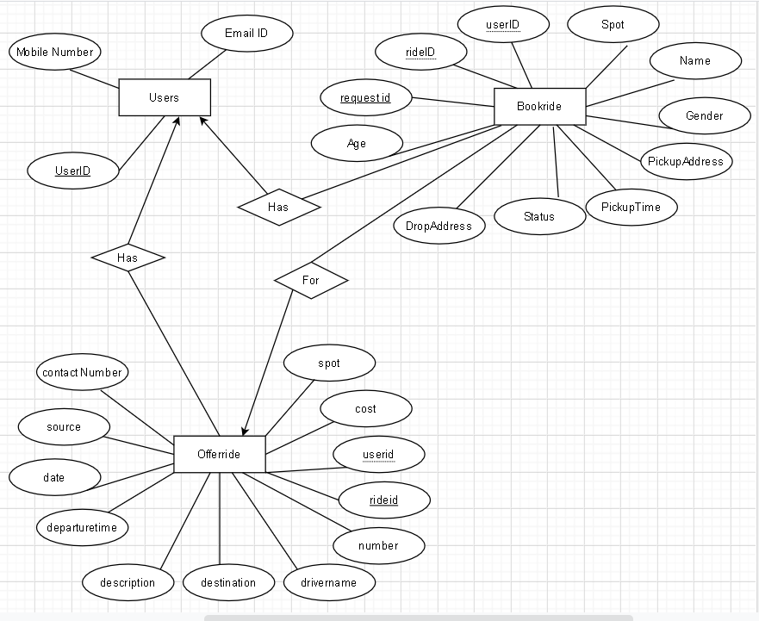

**4.3 Usecase Diagram**

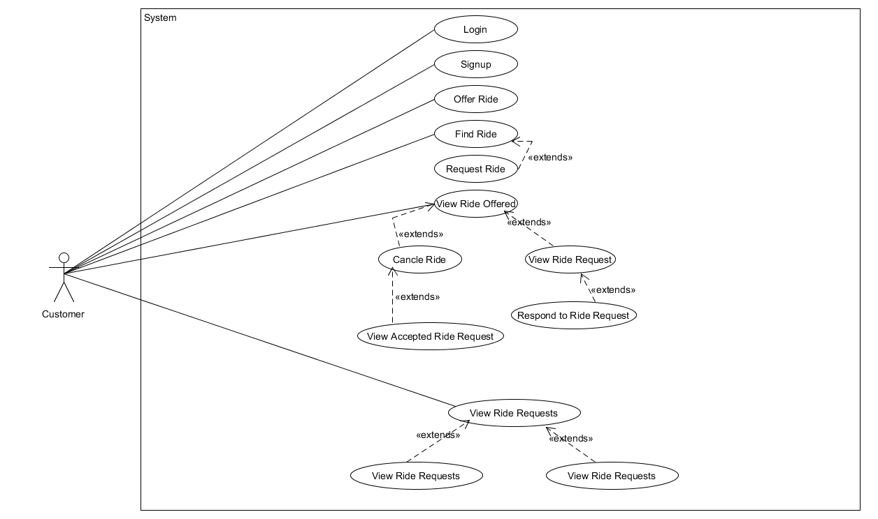

**4.4 Class Diagram**

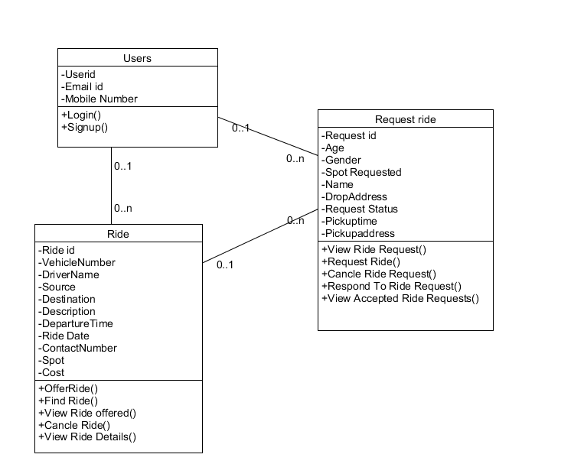

**4.5 Activity Diagram**

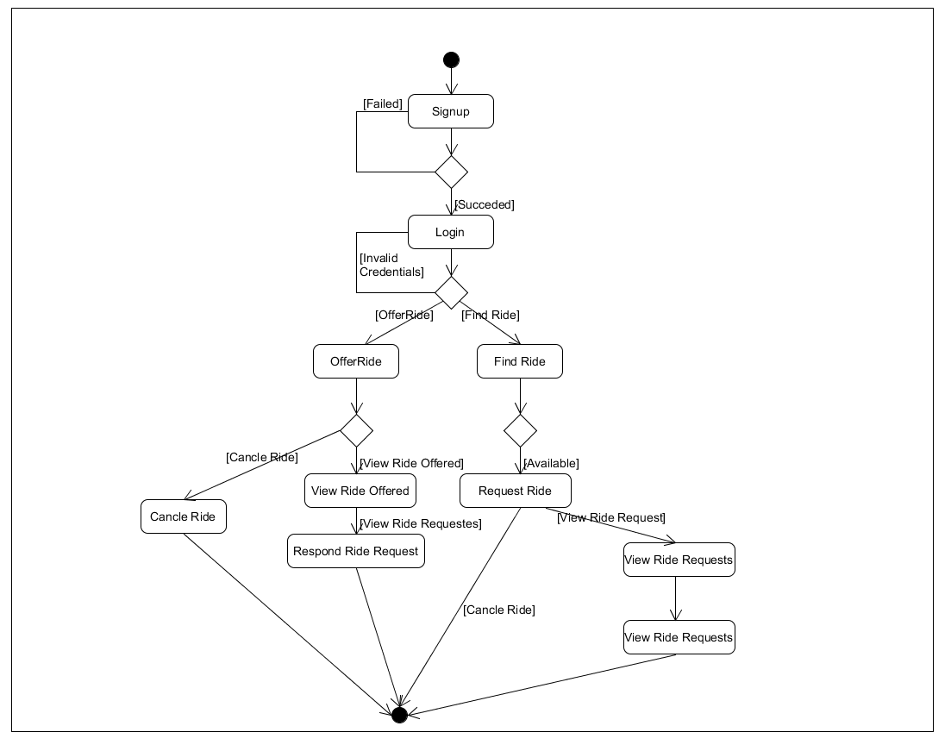

**4.6 Sequence Diagram**

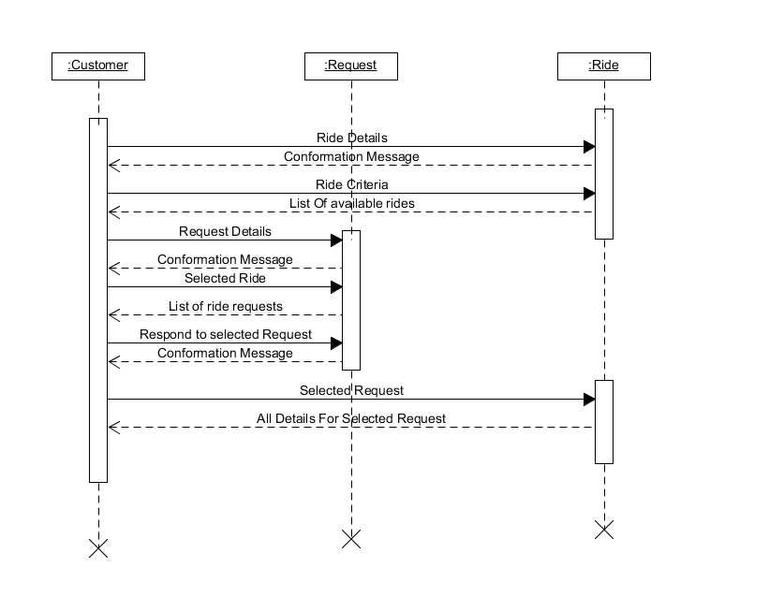

**4.7 State Diagram**

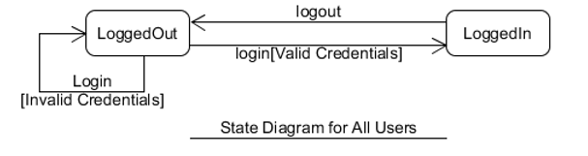

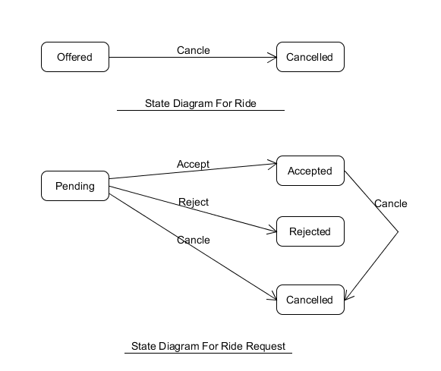

**5.IMPLEMANTATION DETAILS**

**5.1 Modules**

* **Home Module:** This Module Represents the home page of the application and contains navigation for all the functionalities.
* **Login_SignUp Module:** Provides Functionality of login and signup.
* **Offer Ride Module:** This Module Takes all the deatils like Source,Destination,Date of Ride,Expexted Departure Time,Expexted Arrival Time,Free Spots Available in Vehicle,Rate Per Kilometer(Per Person),Vehicle Number,Driver Name,Contact Number,Vehicle Description and allows user to offer a ride.
* **Find Ride Module:**This Module takes all details like Source,Destination,Date Of Journey,No.Of Seats Required from the users and displays available rides.
* **Request Ride Module:** Details like Pick Up Address,Dropping Address,Pick Up Time,Name,Age,Gender are gathered and request is generated for selected ride.
* **AcceptedRides Module:** Displays all the requests accepted for selected ride.
* **AcceptedRidesMain Module:** Displays all the rides offered.
* **CancelPendingRide Module**: Provides functionality to cancel the ride requests in pending state or rejected state.
* **CancelRide Module:** Provides Functionality to cancel accepted ride requests.
* **ViewDetailsViewRidesRequested Module:** Displayes all the requests made for that selected ride.
* **HandelRideCancelled Module:** Provides Functionality To Cancel the Offered Ride
* **Viewrideoffer Module:** Displays All rides offered.
* **ViewRideRequest Module:** Provides functionality to accept or reject ride request.
* **ViewRidesRequested Module:** Provides Functionality To View All the ride requests generated.

**6.TESTING**

In this system we have used Black Box testing.

The main focus of black box testing is on the validation of your functional requirements.

Here are the generic steps followed to carry out any type of Black Box Testing.

* Initially, the requirements and specifications of the system are examined.
* Tester chooses valid inputs (positive test scenario) to check whether SUT processes them correctly. Also, some invalid inputs (negative test scenario) are chosen to verify that the SUT is able to detect them.
* Tester determines expected outputs for all those inputs.
* Software tester constructs test cases with the selected inputs.
* The test cases are executed.
* Software tester compares the actual outputs with the expected outputs.
* Defects if any are fixed and re-tested.

**6.1 Testing Levels**

* Unit testing
* Integration testing
* System testing
* Regression testing
* Acceptance testing

**6.2 Test Cases**

1)User can only signup if provided details are valid, Otherwise error message is displayed.

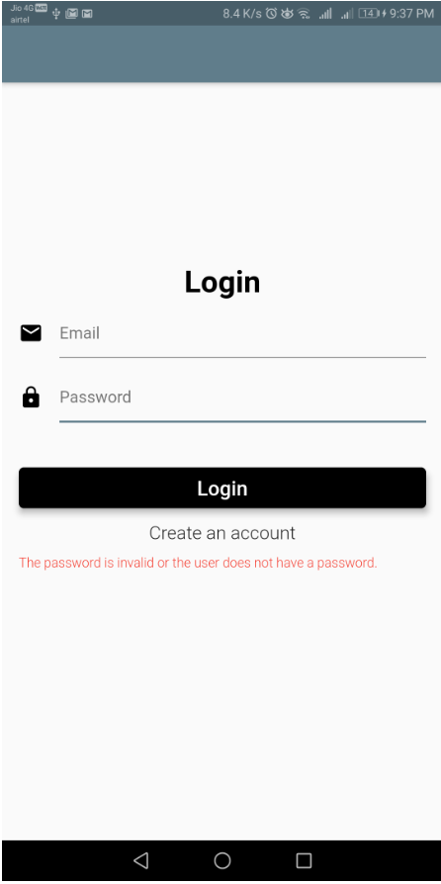

2)User can only login in by providing valid credentials, Otherwise error message is displayed.



**3**) For Finding Rides details must be filled properly else validation messages are displayed.

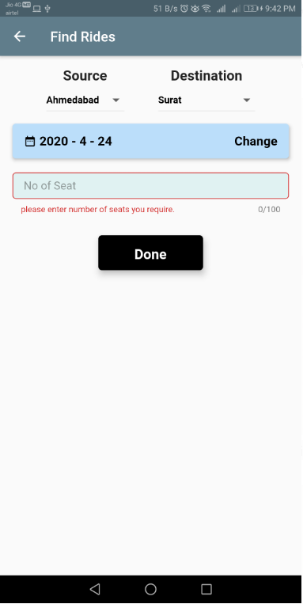

**4**) while requesting ride all details must be filled correctly.

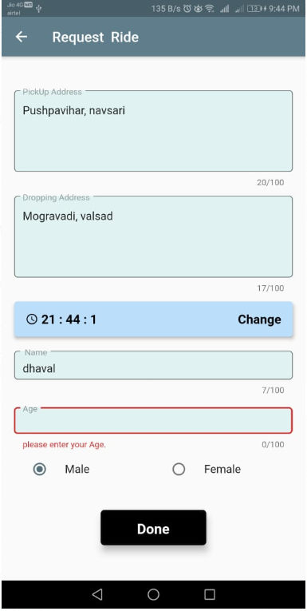

**5)** if there is some error in details required while offering a ride, Error messages are displayed.

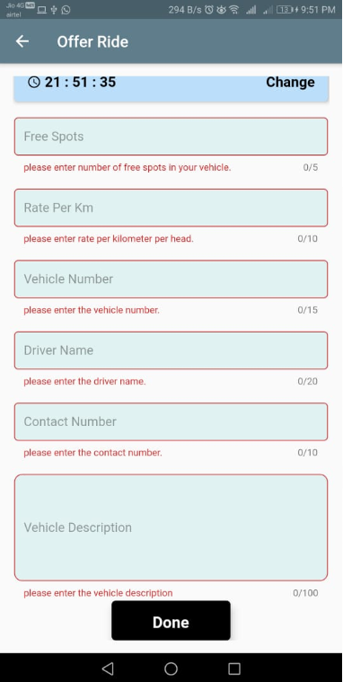

**6)** The total capacity of last ride offered is 10 seats.

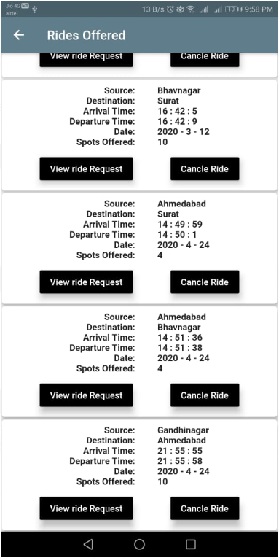

**7)** There are two requests for the ride.one request is for 5 seats.Second Request is for 8 seats. As User Accepts Request with 8 seats.

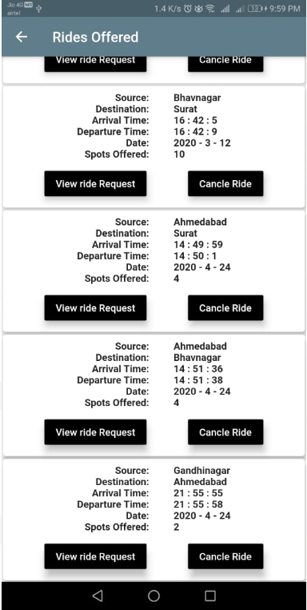

**8)** now remaining seats are only 2

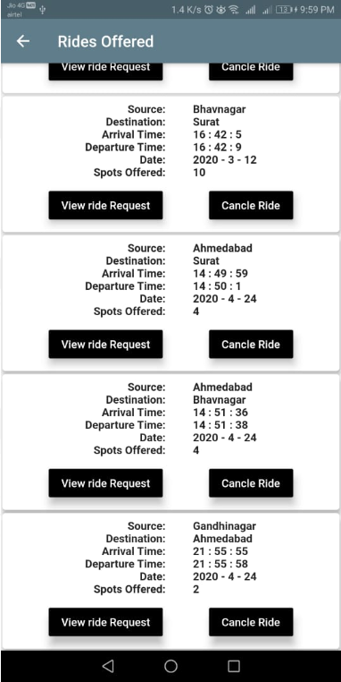

**9**

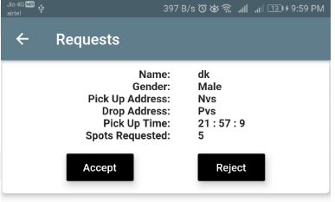

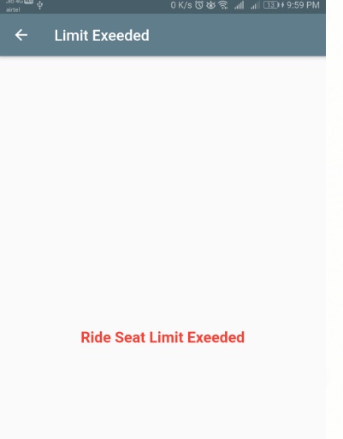

when user tries to accept request for 5 seats ,having only 2 seats left.Error message is displayed.

**7.Screen-Shots**

**1)** Home Screen For User

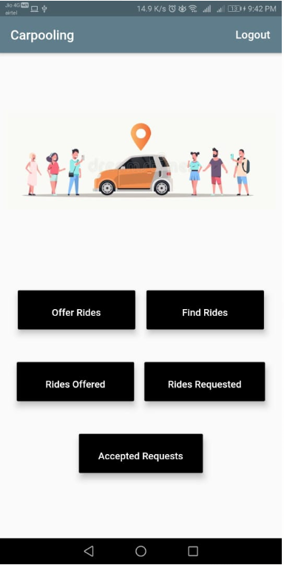

**2)** Find rides

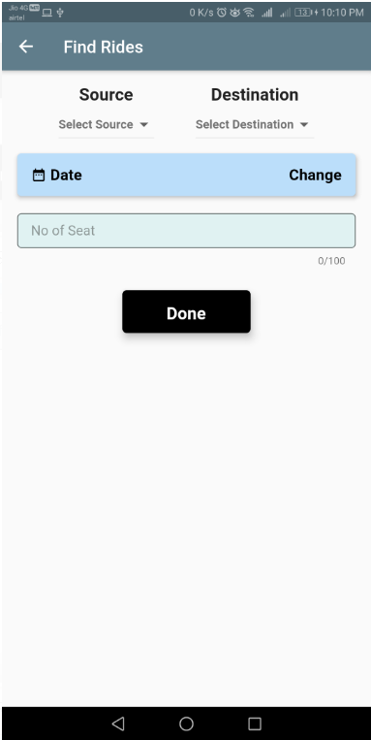

**3)** Offer ride

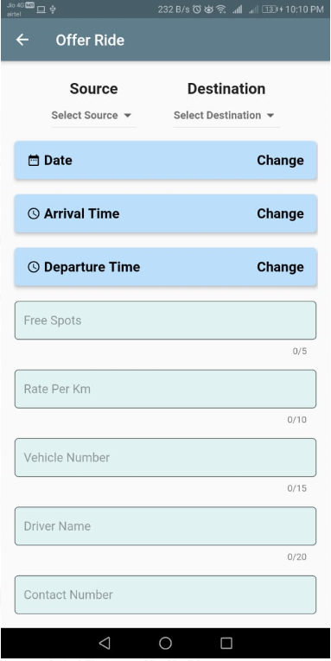

**4)** Rides Offered

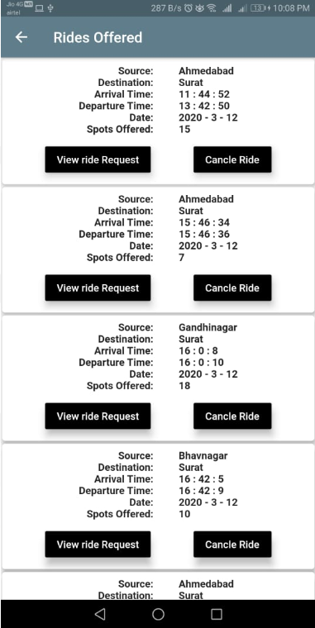

**5)** View Ride Requests

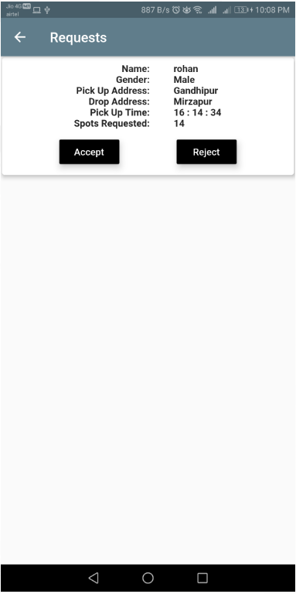

**6)** Ride Requested

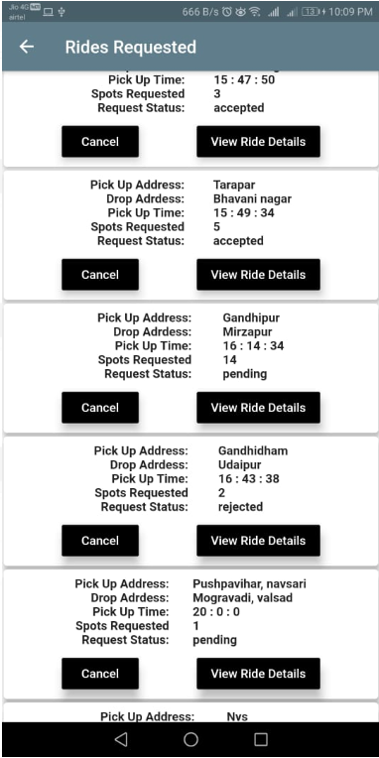

**7)** View Accepted Ride Requests

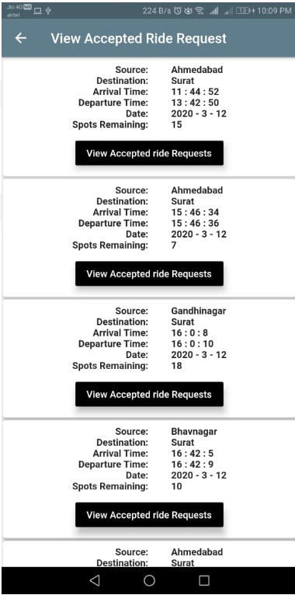

**8.CONCLUSION**

**Functionality Successfully Implemented:**

1.Sign in / Login

2.Sign Up / Register

3.Offer Ride

4.Find Ride

5.Request Ride

6.Cancel Ride

7.Respond To Ride Requests

8.View Ride Requests

9.View Ride Details

10.Cancel Ride Requests

11.View Accepted Ride Requests

12.View Rides Offered

**Above All Functionalities are successfully implemented.**

**9.LIMITATION & FUTURE EXTENSION**

**Limitation Of System:**

The Users can not see exact locations of each other which may cause inconvinience to the users finding each other.It is Difficult to trust strangers sometimes which may prevent few people from using the application.Carpooling requires everyone in the vehicle to be ready to leave at the same time. If you’ve got an early afternoon planned with the family and it’s your week to be in the carpool, then you might be forced to stay at work until everyone else is released from their duties. If someone is running late at work with a project, then everyone is forced to stay behind and wait.

**Future Extention:**

1.Allow Users to rate each other and provide reviews.

2.SMS/Alert for the ride

3.Live Tracking with GPS (using google maps)

4.Chatroom for users to communicate without reveiling contact details.

5.Speech to Text Conversion for better user experience

6.Inclusion of Digital Payment

**10.BIBLIOGRAPHY**

* [**https://flutter.dev/docs**](https://flutter.dev/docs)
* [**https://dart.dev/guides**](https://dart.dev/guides)
* [**https://console.firebase.google.com**](https://console.firebase.google.com/)
* [**https://www.youtube.com/**](https://www.youtube.com/)
* [**https://pub.dev/**](https://pub.dev/)